HEADER IMAGE

(A, B, C, D, E)

Honda Drive-In is an authorized Honda Atlas Cars Pakistan Limited 3S dealership, where we deal in selling and repairing of Honda cars. It is one of the best 3S authorized Honda dealerships where we deliver services with excellence and integrity. Employing under rule-of-thumb that customer is our family. We exclusively deal in genuine Honda parts, premium quality of diagnosis and repairing services, and possible best services of Sales.

Since 20 years, we are delivering excellence and innovations. Earth Dreams Technology (EDT) are one best example - invented by Honda in 2011and it is only installed in latest Honda models.

Earth Dreams Technology is a next generation set of technological advancements which greatly enhance both driving performance and fuel efficiency at a high level, using as its base advanced environmental technologies to pursue the joy of driving unique to Honda. It is a series of measures in which efficiency of internal combustion components including engine, and transmission, as well as electric-powered motor technology, is further improved.

Services

We have a team of experienced and Honda certified technicians and engineers led by professional managers. We guarantee premium quality of diagnosis and repair. After years of providing services we are now totally aware of how to service your Honda car more optimally and make your Honda run as nothing happen. You can trust your vehicle on your hand..!

**Honda Earth Dreams Technology**

Delivering excellence and innovation

Video F

Spare parts

Honda Genuine Maintenance Spare Parts offer a flawless fit to help protect your Honda’s superior performance. Each part is engineered and tested to complement the innovative technology built into your vehicle. You can feel the quality. Honda always prefer to use Honda Genuine Maintenance Parts meet Original Equipment Manufacturers (OEM) standards for endurance. That’s quality, finely tuned! 😊

Sales

Since 20 years of selling excellence, aspirations and positive innovation in shape of Honda cars, proudly saying our Sales Portfolio includes individual customers and big list of corporate clientele. At Sales, our experienced and professional team aims to provide you a best Honda car as per your family or business needs. That’s why we say we sale dreams!

😊

COMPANY OVERVIEW

(H)

(G)

(I)

(J)

State-of-the-art facilities

(K)

(L)

COMPANY PORTFOLIO

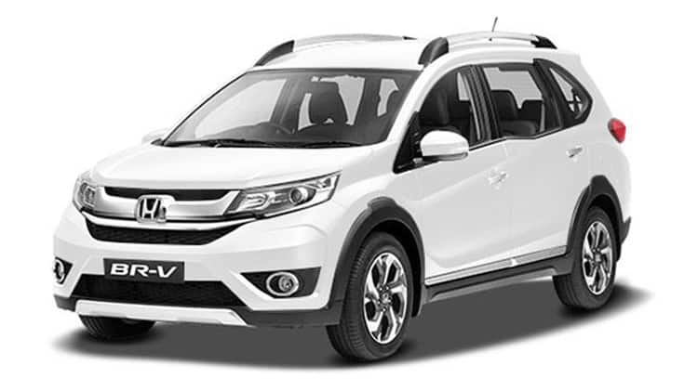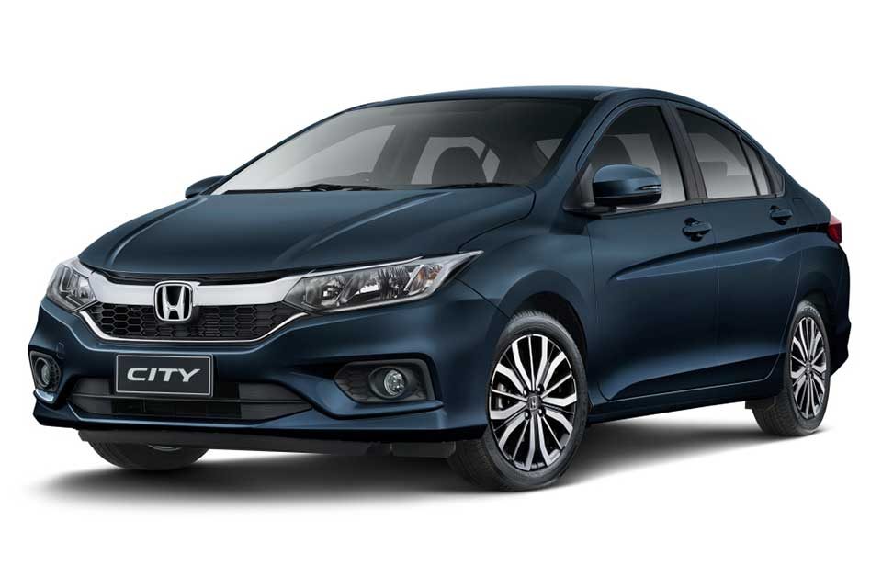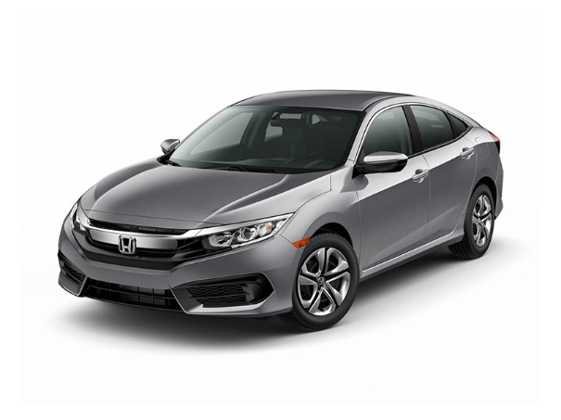

* BR-V i -VTECH MT
* BR-V i -VTECH S
* Civic i - VTECH
* Civic i – VTECH Oriel
* City Manual 1339 cc
* City Prosmatec 1339 cc
* City Manual 1500 cc
* City Prosmatec 1500 cc
* City Aspire Manual
* City Aspire Prosmatec

(N)

(M)